“THE MAKING OF A PEOPLE: NOW YOU SHALL SEE”
Exodus 6:1, 7:14-21, 8:1-15
February 17, 2019
Rev. Janet Robertson Duggins
Westminster Presbyterian Church

That is just the beginning of the story. It takes Pharaoh as long time to hear the message which runs like a refrain through the whole story: “Let my people go.”

The first plague, the water turned to blood,
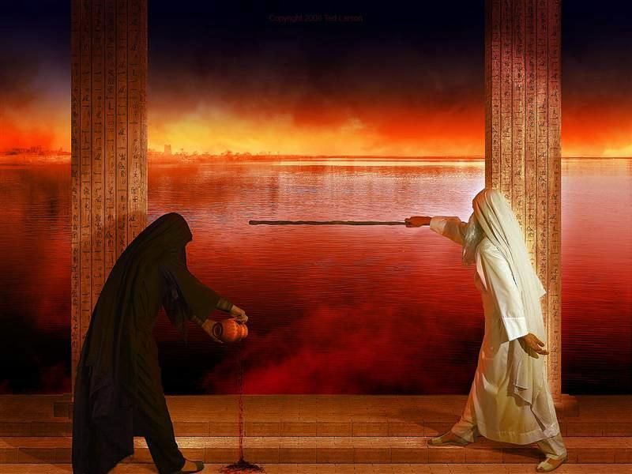
ought to have been enough, but it’s not. At this point, we are surprised to read that the Egyptian magicians too are able to turn water to blood, and perhaps that’s why Pharaoh is not yet ready to take Moses and Aaron – or their God – too seriously. If you find this scene hard to take, it doesn’t get any more pleasant.

A week later, there are frogs.
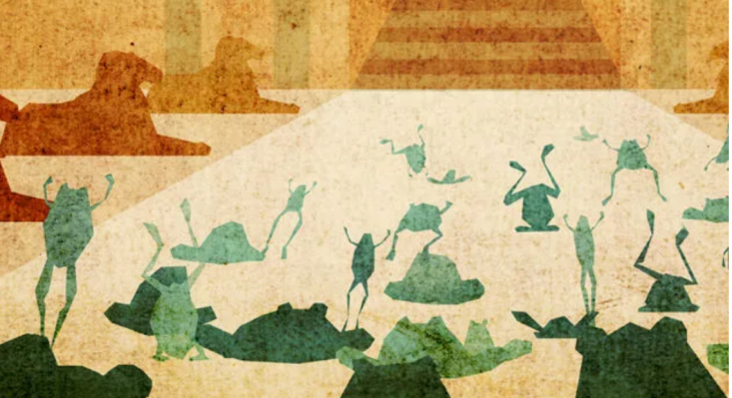
Lots and lots of frogs. Frogs everywhere, and although Pharaoh’s magicians show that they too can conjur frogs, this time Pharaoh tells Moses that the people can go. But when the frogs die – horribly, everywhere – he “hardens his heart” and changes his mind.

And from there the story goes on, for several chapters: each time the word from God, “Let my people go,” each time a different disaster, each time a little bit different reaction from Pharaoh or his people.

Next there are gnats
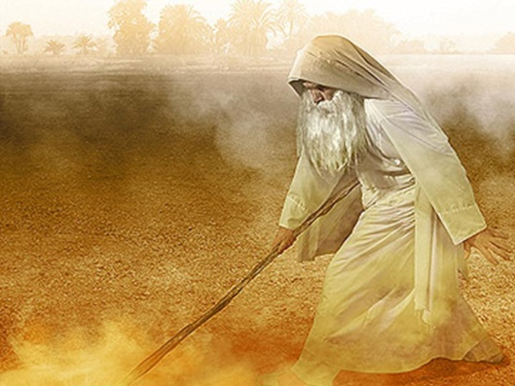
(or mosquitoes – the translation is uncertain) that rise up out of the dust when Aaron strikes the ground, and they afflict both the people and the animals. This time the magicians try to produce the same insects but they cannot, and they say to Pharaoh, “This is the finger of God.” But he won’t listen. We’re told again that his “heart was hardened.”

After that, there are swarms of flies.
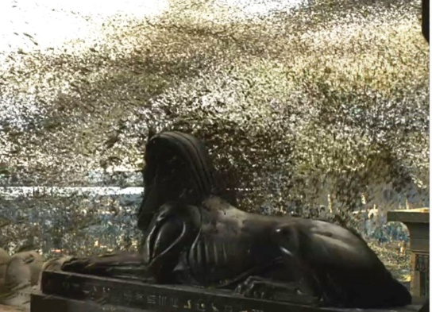
For the first time, we are told that only the Egyptians are affected, and the area where the Hebrew slaves live is not. Pharaoh says, “Ok, your people can have time off to worship your God, but do it here in Egypt.” “No,” Moses says, “God has told us to go three days journey into the wilderness.” Pharaoh says, “I will let you go, but don’t go far. Pray for me.” Moses prays, and the flies go away, but Pharaoh “hardens his heart” and changes his mind.

Next a deadly disease strikes the Egyptian’s livestock.
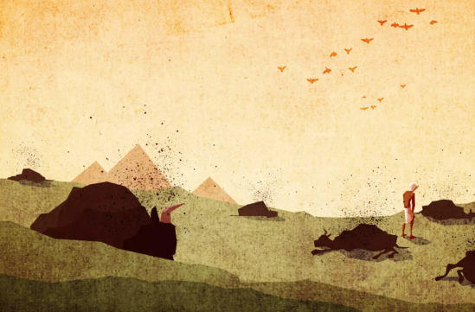
But again Pharaoh’s heart is hardened and he refuses to let the people go.

Then the Egyptians and their animals are afflicted with a skin disease.
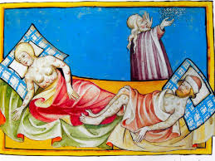
This time we are told that “The Lord hardened the heart of Pharaoh” and he will not listen.

At this point, God gives some rationale, which Moses passes on to Pharaoh: God could have killed off the Egyptians by now but has let them live so that they will know God’s power… which they will shortly see in the worst hail storm ever.
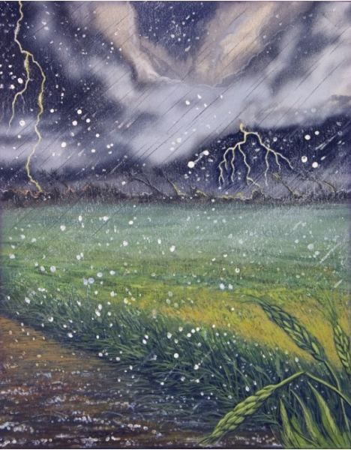
Now Pharaoh says to Moses, “God is right and I and my people are in the wrong. Ask God to stop the hail and I will let you go!” But when the storm stops, his “heart is hardened” again and he will not let the people go.

When Moses and Aaron go to Pharaoh to say that what’s coming next is locusts
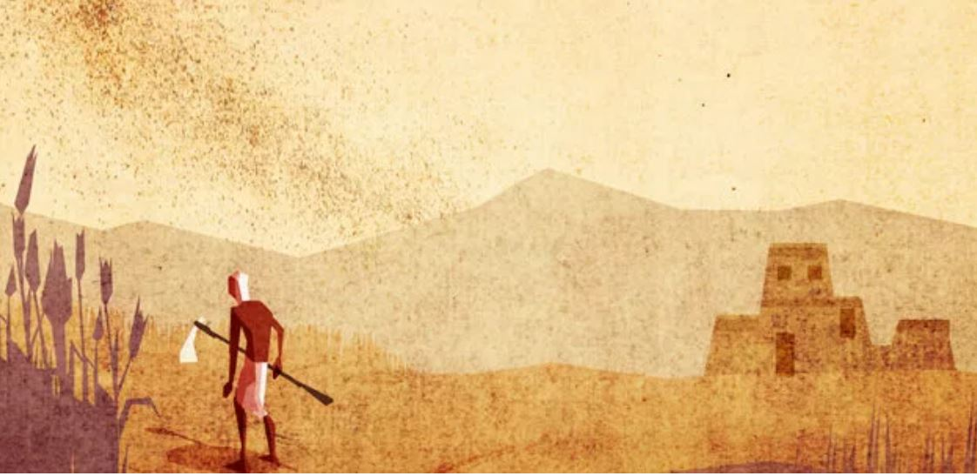
to devour whatever crops remain, Pharaoh’s officials beg him to just let the people go already! So Pharaoh tells Moses “You can go, but leave the children here.” I guess he has realized all along they don’t intend to come back. But that condition isn’t acceptable, of course, so the locusts descend. Pharaoh says, “Forgive me just this once and ask your God to remove the locusts.” But then again “the Lord hardens his heart” and Pharaoh changes his mind.

After that, there is darkness
a dense, paralyzing darkness, throughout Egypt for three days (although we are told the Israelites had light). Now to me that doesn’t sound as bad as insects, but to the Egyptians the absence of sunlight might have seemed like the end of the world. Pharaoh now says, “Go, but leave your animals behind.” “No,” says Moses, “we need them to choose animals for sacrifices to worship God.” Pharaoh will not go along with this, because “the Lord hardened his heart.”

The last plague is clearly a calamity of a different kind.
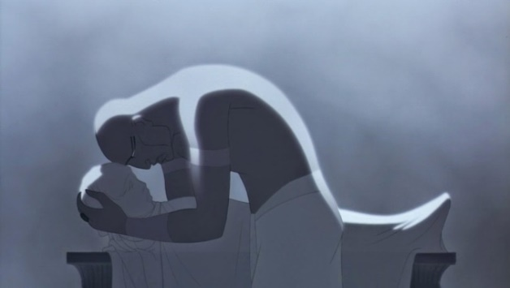
The death of the Egyptian’s firstborn children is what finally breaks down Pharaoh’s stubborn resistance. It really begins the next part of the story that will become the basis for Passover, with the Israelite families being spared this grief and then being led out of Egypt in what we call the “exodus.” Jerry will talk about that more next week.

Today I want to focus on the plagues.
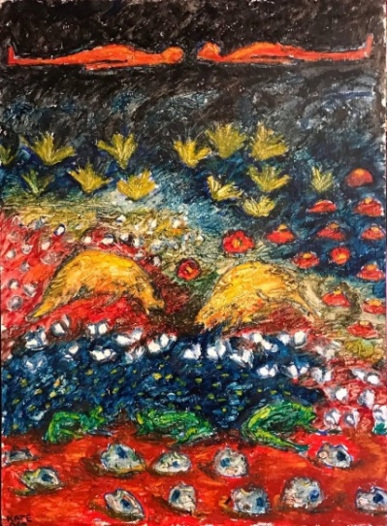 (“Plagues of Egypt” by Kate Orr)

This is a mighty strange series of stories, isn’t it? From one perspective, it’s a story of God’s mighty acts of deliverance. From another, it’s a confrontation with power. It can be read as an account of ecological disasters wreaking havoc on a whole population. You could describe these events as divine miracles of a sort – although this is not the sort of thing we usually think of when we hear the word “miracle”! You could consider possible “scientific” explanations that have been suggested for the phenomena (a volcanic eruption is the most commonly proposed), although that’s a somewhat separate issue from the intent and perspective of the text itself.

You might see the plagues as well-deserved divine retribution for the oppression visited on the Hebrews by the Egyptians – or maybe somehow a representation of the consequences that will eventually plague any society built on injustice and shortsightedness and greed. On the other hand, you might view this story as somewhat troubling in the picture it gives of God. Or… maybe you just are a little grossed out by it, as I was when I first learned these stories as a kid in Sunday School. I can remember pondering which plague would be the worst, though I don’t recall coming to any conclusion.

What are we to make of it?

God’s statement, “Now you shall see what I will do” frames the whole story. God promises to act and God acts. God’s purpose is to deliver the people, but we are also told that God does these things – referred to in the text as “signs” - to make God’s power known. Is that is for the benefit of the Egyptians or also for the Israelites, who might not yet be convinced that God’s going to lead them out of slavery? It’s hard to tell. But over and over the text stresses the power of God.

We should note that Moses and Aaron are involved in every step – Moses relays God’s messages to Pharaoh, Aaron’s rod is somehow a conduit of power to bring on the plagues – these brothers are God’s messengers and act on God’s behalf. God’s way of working in the world is through the people God claims and calls. But it’s very clear that we are not to attribute the deliverance to the leadership or courage of Moses and Aaron. The power at work is God’s.

Commentators have observed that these stories echo the language of the creation stories… except that these are stories of destruction. The unfolding progression of the plagues is a kind of de-creation meant maybe to say that Pharaoh’s regime has violated the moral order of the universe which God intends… leading to consequences that throw nature into chaos. At any rate, it is clear that the One who created the land and water and frogs and insects and weather cycles and light and life retains the power over all of it … to take it apart and put it back together again.

Two phrases recur like refrains throughout, both of which challenge us:

“Pharaoh’s heart was hardened.” It’s interesting and puzzling that sometimes we are told that Pharaoh hardened his heart, and sometimes we are told that God hardened Pharaoh’s heart, and sometimes it’s ambiguous: “Pharaoh’s heart was hardened.” Reflection on the different phrasing gets us into the thorny and unanswerable question of where human freedom and autonomy leave off and where God’s sovereignty begins. It’s the flip side of the question of grace and freedom – to what extent do we choose God and to what extent is even our choice enabled by God’s grace? Here we can see that Pharaoh has a choice – and chooses wrongly, repeatedly – but eventually it seems that he’s no longer able to choose otherwise. It’s almost as if God finally decrees that Pharaoh has to keep that hard heart he has cultivated. This only serves to emphasize that God’s will and not Pharaoh’s hard heart will rule the day.

“His heart was hardened” seems to me one of the saddest of Biblical phrases. It’s not only used here of Pharaoh; elsewhere in the Old Testament God and God’s prophets use this image of “hardened hearts” to refer to the people of Israel at times when they ignore God and neglect the obligations of community and justice and compassion for the vulnerable. It speaks of the closing off of the spirit to all vulnerability, compassion, kindness and wisdom.

It’s a sobering phrase, a warning to everyone who hears the story: Don’t harden your heart. Don’t allow your heart to be hardened. Don’t let yourself become complacent in privilege, numb to the suffering of others, unable to feel compassion, unwilling to hear truth, deaf to God’s words. Not only will you be standing in the way of God’s will, you might eventually find yourself unable to be again a fully human person capable of giving and receiving love.

When we read these stories, we have to ask ourselves: how are we like Pharaoh, hardening our hearts and refusing to listen? Are there people we need to free from limitations, stereotypes, cycles of poverty and injustice? Are there groups whose voices we need to hear? Are we shutting our ears and hearts and minds to God’s call?

The other phrase that recurs in this stories is “Let my people go.” Simple words but so powerful, because they come to us as God’s words; not only that, each time they are repeated the power of the message builds. It’s no wonder “let my people go” became the refrain of a powerful African-American spiritual composed around the time of the Civil War; “Go Down Moses” was both a cry for freedom for the millions of men, women and children enslaved in the United States and testimony to the belief that God willed their freedom.

You can’t get around the fact that these stories are about confronting the powers that be and demanding change and justice. Can I just say it? This is a political story. If there is any part of the Bible that refuses to be a source of purely personal and private spirituality, this is it. Real justice in the real world is not separable from God’s other intentions for humanity. It is unequivocally clear here that God is on the side of the powerless. Surely this should give us pause, because we do so often seem to forget that. I know that isn’t particularly comfortable or comforting, but don’t think there is any way to spin it differently.

This is not a sweet or pretty story. Maybe that is an acknowledgement of reality: deliverance is not without cost. The powerful are not just gonna give it up. Anger and denial and resistance and false promises are to be expected.… A part of the message here is certainly an encouragement to persist in standing up to the those who will do anything, accept any kind of consequences to maintain power.

Troubling questions still remain though: Didn’t God love the Egyptians too? Yes, they enslaved the Hebrew people. But surely they were not all equally culpable! Some of them were probably almost as powerless as the Hebrew slaves. And the plagues really are pretty harsh. Yes, they are signs of God’s power. Yes, they demonstrate the depth of God’s determination to free the Hebrews from slavery and make them into a people belonging to God. But the plagues do remind us that God is not “tame” and that we have a faith tradition that encompasses some history and stories we can’t entirely understand or feel comfortable with. Perhaps all we can honestly do is acknowledge that.

I discovered some contemporary Jewish resources that gave me some ideas about engaging faithfully with the richness and strangeness of these plague stories.

In a typical Passover Seder liturgy, all the plagues are listed and described, one after the other. With the naming of each one, a drop of wine is removed from the cup. “We cannot drink a full cup of wine,” the leader says, “when our freedom comes through the suffering of others.” I really like that acknowledgement of this unexplainable but troubling piece of the faith tradition, and the deliberate choice to let it temper the joy a little bit. I wonder if there are ways we might actively, intentionally, regularly remember how we have benefitted from the suffering or the work or the oppression of others, and allow that knowledge to temper our joy or self-satisfaction.

I also discovered that modern Seders sometimes name or reflect on various modern “plagues’ that are the result of structural injustice or greed or refusal to live in ways that respect other people or the earth. Hunger, poisoned water, drought, floods, die-off of pollinator species, mass extinctions, preventable diseases, infant mortality, wildfires, oil spills …it’s not hard to name ten. The ancient story then becomes more than a strange tale, it becomes a reminder that there are still pharaohs to confront, still sins that have devastating and far-reaching consequences, still freedoms and causes to champion… and there is still a God who cares about such things and the vulnerable people they hurt, and that God is the God to whom we belong.

Amen

Resources:
Exodus (Interpretation Commentary) by Terrence Fretheim

